1. **What is activity planning?**

Ans: The activity plan of a project refers to the process of thinking about and organizing the activities required to achieve a desired goal. It involves defining the value proposition delivery strategy and developing the scoped product efficiently, with minimal waste or burden.

1. **What are the objectives of activity planning?**

Ans:

1. Feasibility Assessment: Determine if the project can be completed within the specified timeframes and budget constraints, considering factors like technology feasibility, market demands, and available expertise.
2. Resource Allocation: Assign the necessary human resources, such as developers, testers, and designers, as well as technological resources like software tools and infrastructure, to different tasks and stages of the project.
3. Detailed Costing: Estimate and track the costs associated with software development, including expenses for personnel, software licenses, hardware, and other resources required throughout the project lifecycle.
4. Motivation: Keep the project team motivated and focused on achieving milestones by providing clear goals, recognizing achievements, and addressing any issues or obstacles that may arise during development.
5. Coordination: Coordinate the activities of various teams and stakeholders involved in the project, such as developers, QA testers, project managers, and clients, to ensure effective communication, collaboration, and alignment with project objectives and timelines.
6. **Define the steps of project schedules.**

Ans:

1. Ideal Activity Plan: Create a sequence of tasks with estimated durations and dependencies to form a preliminary schedule.
2. Activity Risk Analysis: Identify and evaluate potential risks associated with each task, developing strategies to mitigate them.
3. Resource Allocation: Assign resources to tasks based on availability and requirements, adjusting the schedule accordingly.
4. Schedule Production: Finalize and communicate the detailed timeline for each task, continuously monitoring and updating it throughout the project.
5. **What are the assumptions about CPM?**

Ans:

1. Identifying Activities: Each task in a software project has a clear start and end point, like designing a user interface or writing code for a feature.
2. Sequencing Activities: Tasks are arranged in a specific order, showing which ones need to be completed before others can start. For instance, testing can't happen until coding is done.
3. Critical Path Focus: We focus on the most crucial tasks that determine how long the project will take. For example, if coding takes the longest time, we need to ensure it stays on track.
4. Activity Time Distribution: Task durations in software projects can vary, so we should pay close attention to those with the most impact on the project's overall timeline, like fixing bugs or integrating different software components.
5. **Define the different categories of risks.**

Ans: There are 3 categories of risks. Such as:

1. Schedule Risk: This happens when project tasks take longer than expected or when release dates are missed, potentially causing the project to fail.

Examples:

* Thinking a task will take two weeks but it actually takes four, delaying the whole project.
* Not having enough people or tools to do the work, causing delays.
* Not realizing how complicated a task is, so it takes much longer than planned.
* Adding extra work to the project without adjusting the schedule, causing delays.

1. Budget Risk: This is when the project costs more than planned, either because we didn't guess right or because we added more stuff to the project.

Examples:

* Thinking a project will cost $10,000 but it ends up costing $15,000.
* Spending more money than planned because things come up that we didn't expect.
* Adding extra features to the project without adding extra money, so we run out of budget.

1. Operational Risks: These are risks that come from not doing things right within the team or the project, like not talking enough or not planning well.

Examples:

* People arguing about what's most important, slowing down the work.
* Not knowing who's supposed to do what, causing confusion.
* Not having enough people or tools to do the work properly.
* Not teaching people how to do their jobs well, so they make mistakes.
* Not planning things out carefully, so everything takes longer than it should.
* Not talking to each other enough, so everyone does things differently and it causes problems.

1. **How are major risks addressed in the Risk Response Planning process, and why is assigning risk owners important?**

Ans: When we identify major risks in a project, we assign each one to someone responsible for keeping an eye on it. This helps make sure we don't overlook any risks that could cause problems.

For each major risk, we choose one of these ways to deal with it:

1. Avoid: We try to get rid of the risk altogether, either by fixing the problem causing it or finding a way around it. For example, if there's a risk of data loss, we might back up our files regularly to avoid losing important information.
2. Mitigate: We look for ways to lessen the chance of the risk happening or reduce its impact if it does occur. For instance, if there's a risk of delays due to bad weather, we might schedule outdoor work during the dry season to minimize disruptions.
3. Accept: Sometimes, we decide it's best to just accept the risk and not do anything about it. This could be because the risk is unlikely to happen or its impact is manageable.
4. Contingency: We plan ahead for what to do if the risk does happen. For example, if there's a risk of key team members getting sick, we might have backup plans in place so the project can continue even if someone is absent.
5. Transfer: We pass the risk on to someone else, like an insurance company or another party who's better equipped to deal with it. For instance, if there's a risk of financial loss, we might buy insurance to protect ourselves against it.
6. **Briefly define some hazard analysis methods.**

Ans: Hazard Analysis Methods help identify and understand potential dangers in a system or process. Here are two common methods:

1. Failure Modes & Effects Analysis (FMEA):

* Breaks down the hardware into its components and examines how each part could fail.
* Considers how these failures might affect other parts, subsystems, or the entire system.
* Assesses the severity and likelihood of each failure, assigning a Risk Assessment Code (RAC) to prioritize them.

1. Fault Tree Analysis (FTA):

* Focuses on a specific undesired event, examining its causes in detail.
* Takes a deductive approach, starting with the event and working backward to identify its root causes.
* Typically used for critical failures or mishaps and can be qualitative or quantitative in nature.

Additionally, there's Operating Hazard Analysis (OHA):

* Also called Operating & Support Hazard Analysis (O&SHA), it's a "what-if" tool involving users in identifying potential hazards.
* Integrates people and procedures into the analysis, often through flow diagrams or sequence of events diagrams.
* Project Evaluation Tree (PET) may be utilized for systematic evaluation of man, machine, and procedures in OHA.

1. **Draw the diagram of the risk management process and briefly explain each step.**

Ans: 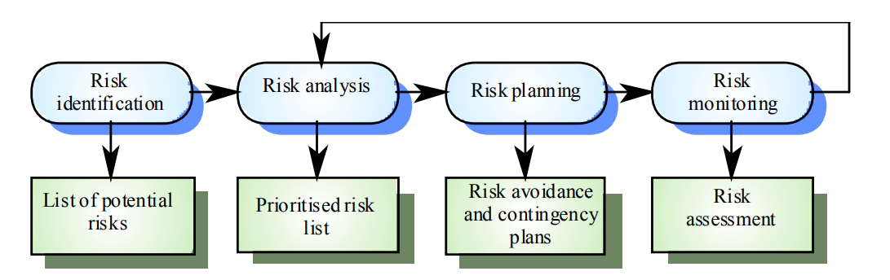

1. Risk Identification: In this phase, the team systematically lists potential project risks, considering factors like people, size, process, technology, tools, organizational and managerial issues, customer requirements, and estimation accuracy, to anticipate and address challenges before they escalate.
2. Risk Analysis: Evaluate how likely each risk is to occur and the potential impact it could have on the project.
3. Risk Planning: Develop strategies to either prevent the occurrence of risks or mitigate their effects if they do occur.
4. Risk Monitoring: Continuously observe and track identified risks throughout the project to ensure timely responses and adjustments as necessary.
5. **What are the causes of operational risks?**

Ans:

* Failure to address priority conflicts.
* Failure to resolve the responsibilities.
* Insufficient resources.
* No proper subject training.
* No resource planning.
* No communication in team.

1. **Briefly explain the two types of project costs.**

Ans:

1. Project Indirect Costs: These are expenses not directly linked to specific tasks, like management salaries or office rent.

Example: If a software project takes longer than planned, the rent for the office space where the team works increases over time, adding to the project's indirect costs.

1. Project Direct Costs: These are costs directly tied to specific tasks, such as wages for developers or the cost of software licenses.

Example: Hiring additional developers to finish a project faster increases direct costs because you're paying more in salaries.

1. **What assumptions are made when determining which activities to shorten in constructing a Project Cost–Duration Graph?**

Ans:

1. Linear Cost Relationship: It's assumed that the relationship between cost and time is linear, meaning the cost increases steadily with time reduction.
2. Efficient Normal Time: Normal time assumes the usage of efficient and cost-effective methods to complete the activity within a reasonable timeframe.
3. Crash Time Limit: Crash time represents the maximum feasible reduction in time under realistic conditions, beyond which further reduction is not possible.
4. Constant Cost Slope: The slope of the cost-time curve remains constant, indicating that the cost per unit of time reduction remains consistent.
5. Acceleration within Time Limits: Any acceleration efforts must occur within the normal and crash time limits to maintain feasibility.